**BERKAY AKTÜRK**

**Question 1:**

Write SQL code in a word document that will answer the questions below using the following two tables.

Inventory position table

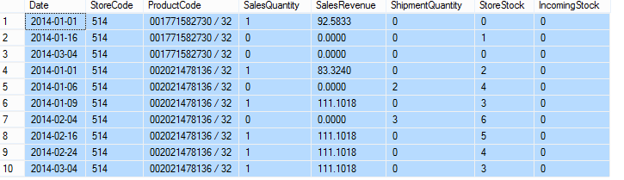

Store table

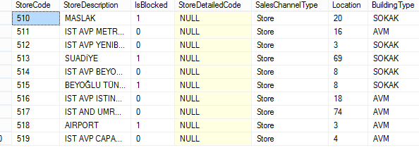

* **Find the latest StoreStock for each StoreCode, ProductCode pair**

WITH LatestDates AS (

SELECT StoreCode, ProductCode, MAX(Date) as MaxDate

FROM InventoryPosition

GROUP BY StoreCode, ProductCode)

SELECT IP.StoreCode, IP.ProductCode, IP.StoreStock

FROM InventoryPosition IP

JOIN LatestDates LD ON IP.StoreCode = LD.StoreCode

AND IP.ProductCode = LD.ProductCode

AND IP.Date = LD.MaxDate

* **Sum sales by BuildingType**

SELECT S.BuildingType, SUM(IP.SalesRevenue) AS TotalSales

FROM InventoryPosition IP

JOIN Store S ON IP.StoreCode = S.StoreCode

GROUP BY S.BuildingType

* **List stores description which have sales revenue lower than 50TL in 2014 May**

SELECT DISTINCT S.StoreDescription

FROM InventoryPosition IP

JOIN Store S ON IP.StoreCode = S.StoreCode

WHERE IP.SalesRevenue < 50

AND YEAR(IP.Date) = 2014

AND MONTH(IP.Date) = 5

* **In February 2014, what is the difference between the highest-selling store and the least-selling store?**

WITH MonthlySales AS (

SELECT IP.StoreCode, SUM(IP.SalesRevenue) AS TotalSales

FROM InventoryPosition IP

WHERE YEAR(IP.Date) = 2014 AND MONTH(IP.Date) = 2

GROUP BY IP.StoreCode)

SELECT (MAX(MS.TotalSales) - MIN(MS.TotalSales)) AS SalesDifference

FROM MonthlySales MS